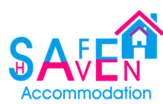

STATEMENT OF
PURPOSE
(South Division)



Contents
- Introduction
- Our Service
- Leadership & Management Standard
- Protection Standard
- Accommodation Standard
- Support Standard
- Review & Updates

- Introduction
At Safe Haven (Support-Care-Education) Group, our Statement of Purpose guides our commitment to providing the best support for the young people in our supported accommodation. It's a clear, transparent document that outlines why we exist, what we aim to achieve, and how we operate. Our approach to completing the document is to make it informative and an interactive useable document by the reader.
By following regulations outlined in the Supported Accommodation Regulations (England) 2023, we ensure that every aspect of our support meets the highest standards. This statement isn't just paperwork; it's a living guide that we regularly update to keep improving our support for young people. We share it openly with everyone involved, ensuring everyone knows what we stand for and how we're dedicated to their well-being.
For a comprehensive understanding, access the full regulation here;
Full Regulations |  | Guide to the Supported Accommodation Regulations and Quality Standards | 
Safe Haven Accommodation is now part of the Safe Haven (Support – Care – Education) Group that formed in January 2024. The group offers varied services across the country that include:
Supported Accommodation- Young People | Childrens Residential Homes | Adults Supported Living  (CQC Registered) | Alternate Education Provision of Excellence
 | 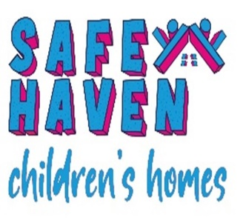 | 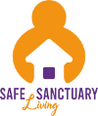 | 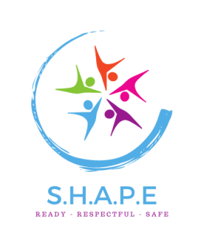

Registered Provider Address:
Safe Haven (Support – Care – Education) Group, 3.1 Clarendon Park, Clumber Avenue, Nottingham, NG5 1AH
Telephone: | 0115 998 6734 | Email: | Info@safehaven-group.co.uk

Registered Service Address:
Safe Haven Accommodation Limited (South Division), 28 Northumberland Road, Bristol BS6 7BB.
Telephone: | 0115 998 6734 | Email: | Info@safehaven-group.co.uk

Category of Supported Accommodation Offered is:
Single Occupancy | Ring-fenced Shared Accommodation | Shared Accommodation  (Non Ring-fenced)

- Our Service
This statement of purpose outlines the support services that Safe Haven Accommodation South Division provides to young people aged 16 and upwards, in alignment with the Ofsted regulations of 2023. We aspire to create an environment that fosters personal growth, independence, and a sense of belonging for the Young People we support.
Safe Haven Accommodation is part of the Safe Haven (Support – Care – Education) Group and have been providing supported accommodation services for over 10 years and have built up a good reputation during this time offering a good, quality service to young people aged 16 and upwards.
Safe Haven (Support – Care – Education) Group Ethos, Aims and Objectives:
Our Mission:
Our mission is to deliver a supportive and empowering service which enables us to deliver high quality support, care, and education.
Our Values:
Our core values and principles promote accountability which enables us to stay focused on well-being, keeping people safe from harm and supporting them to achieve their full potential.
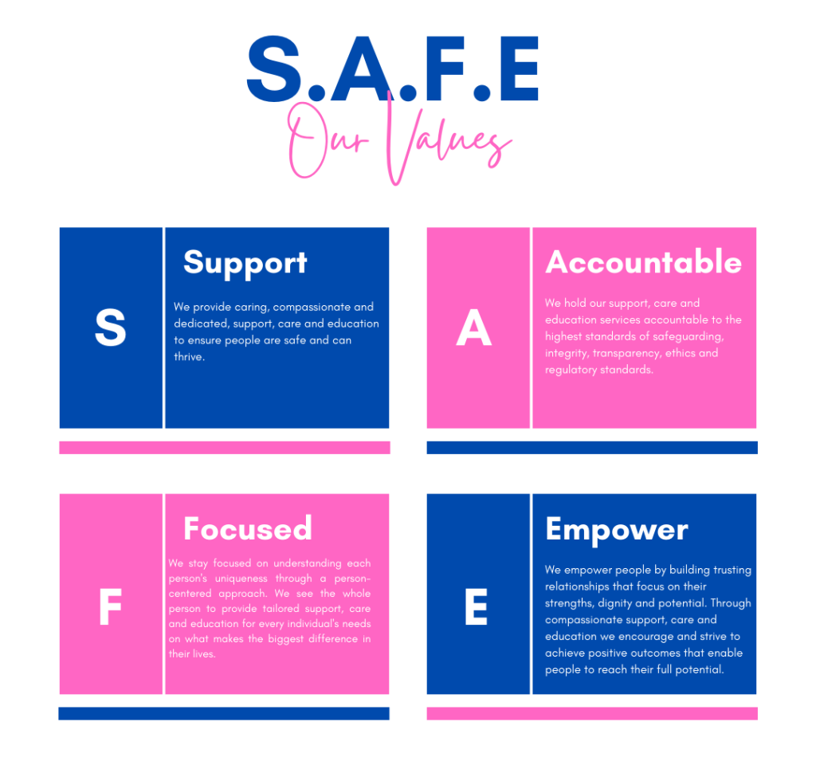

Our Aims & Objectives:
The aims and objectives of Safe Haven Accommodation underscore our dedication to providing a nurturing and supportive environment for the young people we support. Our aims and objectives serve as guiding principles that shape our service delivery and inform our interactions with young people. In alignment with our commitment to promoting positive outcomes, Safe Haven Accommodation aims to create an environment where young people feel empowered, supported, and equipped with the tools they need to thrive.
Through personalised support and interventions, we strive to facilitate the achievement of key outcomes as stated in our SHSA-SS-006 Positive Outcomes Policy and listed below. These outcomes and objectives are based and derived on the principles of supported accommodation, ensuring that all young people have the opportunity to realise their full potential and lead fulfilling lives.
Table 1: Our Objectives
Positive Outcomes | Explanation & Context
Feeling happy and content | Young person experiences a sense of happiness and contentment in their daily life, indicating emotional well-being and satisfaction with their circumstances.
Feeling healthy and positive well-being | Young person actively engages in activities that promote physical and mental well-being, fostering a healthy lifestyle and resilience against health challenges
Engagement in some form of education, employment, or training. | Young person actively attends classes, vocational programs, or job placements, demonstrating commitment to personal development and future prospects
Registration with local health services | Young person is enrolled with a local GP, dentist, and optician, ensuring access to essential healthcare services and regular check-ups.
Feeling safe, happy, and secure in their home | Young person expresses feelings of comfort, security, and belonging within their accommodation, feeling, and experiencing emotional stability and well-being.
A positive support network and social circle | Young person has formed and engages meaningful relationships with peers, family, mentors, or community members, providing emotional support and social connections
Active participation in the local community | Young person engages in community activities, volunteering, or events, contributing positively to the local area and feels a sense of belonging.
Positive self-esteem and optimism about the future | Young person displays confidence, self-worth, and a hopeful outlook towards their personal growth and future goals, dreams and prospects.
Skills, knowledge, and resilience for independent living | Young person demonstrates proficiency in essential skills as per the SAFE Model.
Keeping Safe and making positive choices. | Young person prioritises their safety and well-being through informed decision-making and responsible behaviour, minimising risks and has coping strategies to keep them safe and positive.
Recognition of personal needs and priorities | Young person demonstrates awareness of their own needs, values, and aspirations, enabling them to make informed decisions and advocate for themselves effectively
Moved into a supportive environment of their choice | Young person successfully moves into a stable and suitable living arrangement, whether it be with family, friends, or independent accommodation, ensuring continued support and stability. Being presented as homeless doesn’t not equate to a positive outcome.

Organisational Structure:

Supported Accommodation Services operate nationally and are supported via our head office function in Nottingham which houses the central support departments:
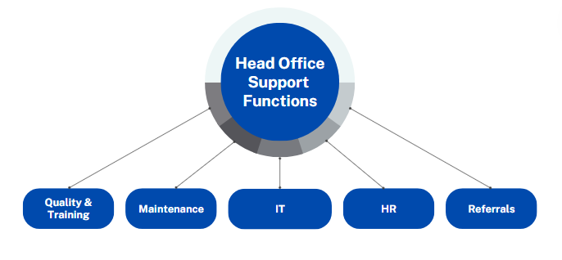

Senior Leadership Team Structure
The senior leadership team have a wealth of experience both in Supported Accommodation and Children’s residential services and Education.

Rob Measures leads the referral team and manages relationships between Safe Haven Accommodation and all placing authorities. Rob has been employed since January 2023 and has 18 years of experience working in the care sector, both residential and supported accommodation services. | Gareth Herbert leads and oversees the Supported Accommodation Services and is the Nominated Individual for the Service.  Gareth's experience and background are provided in depth in the Leadership & Management section of the Statement of Purpose on Page 6.

South Service Team Structure
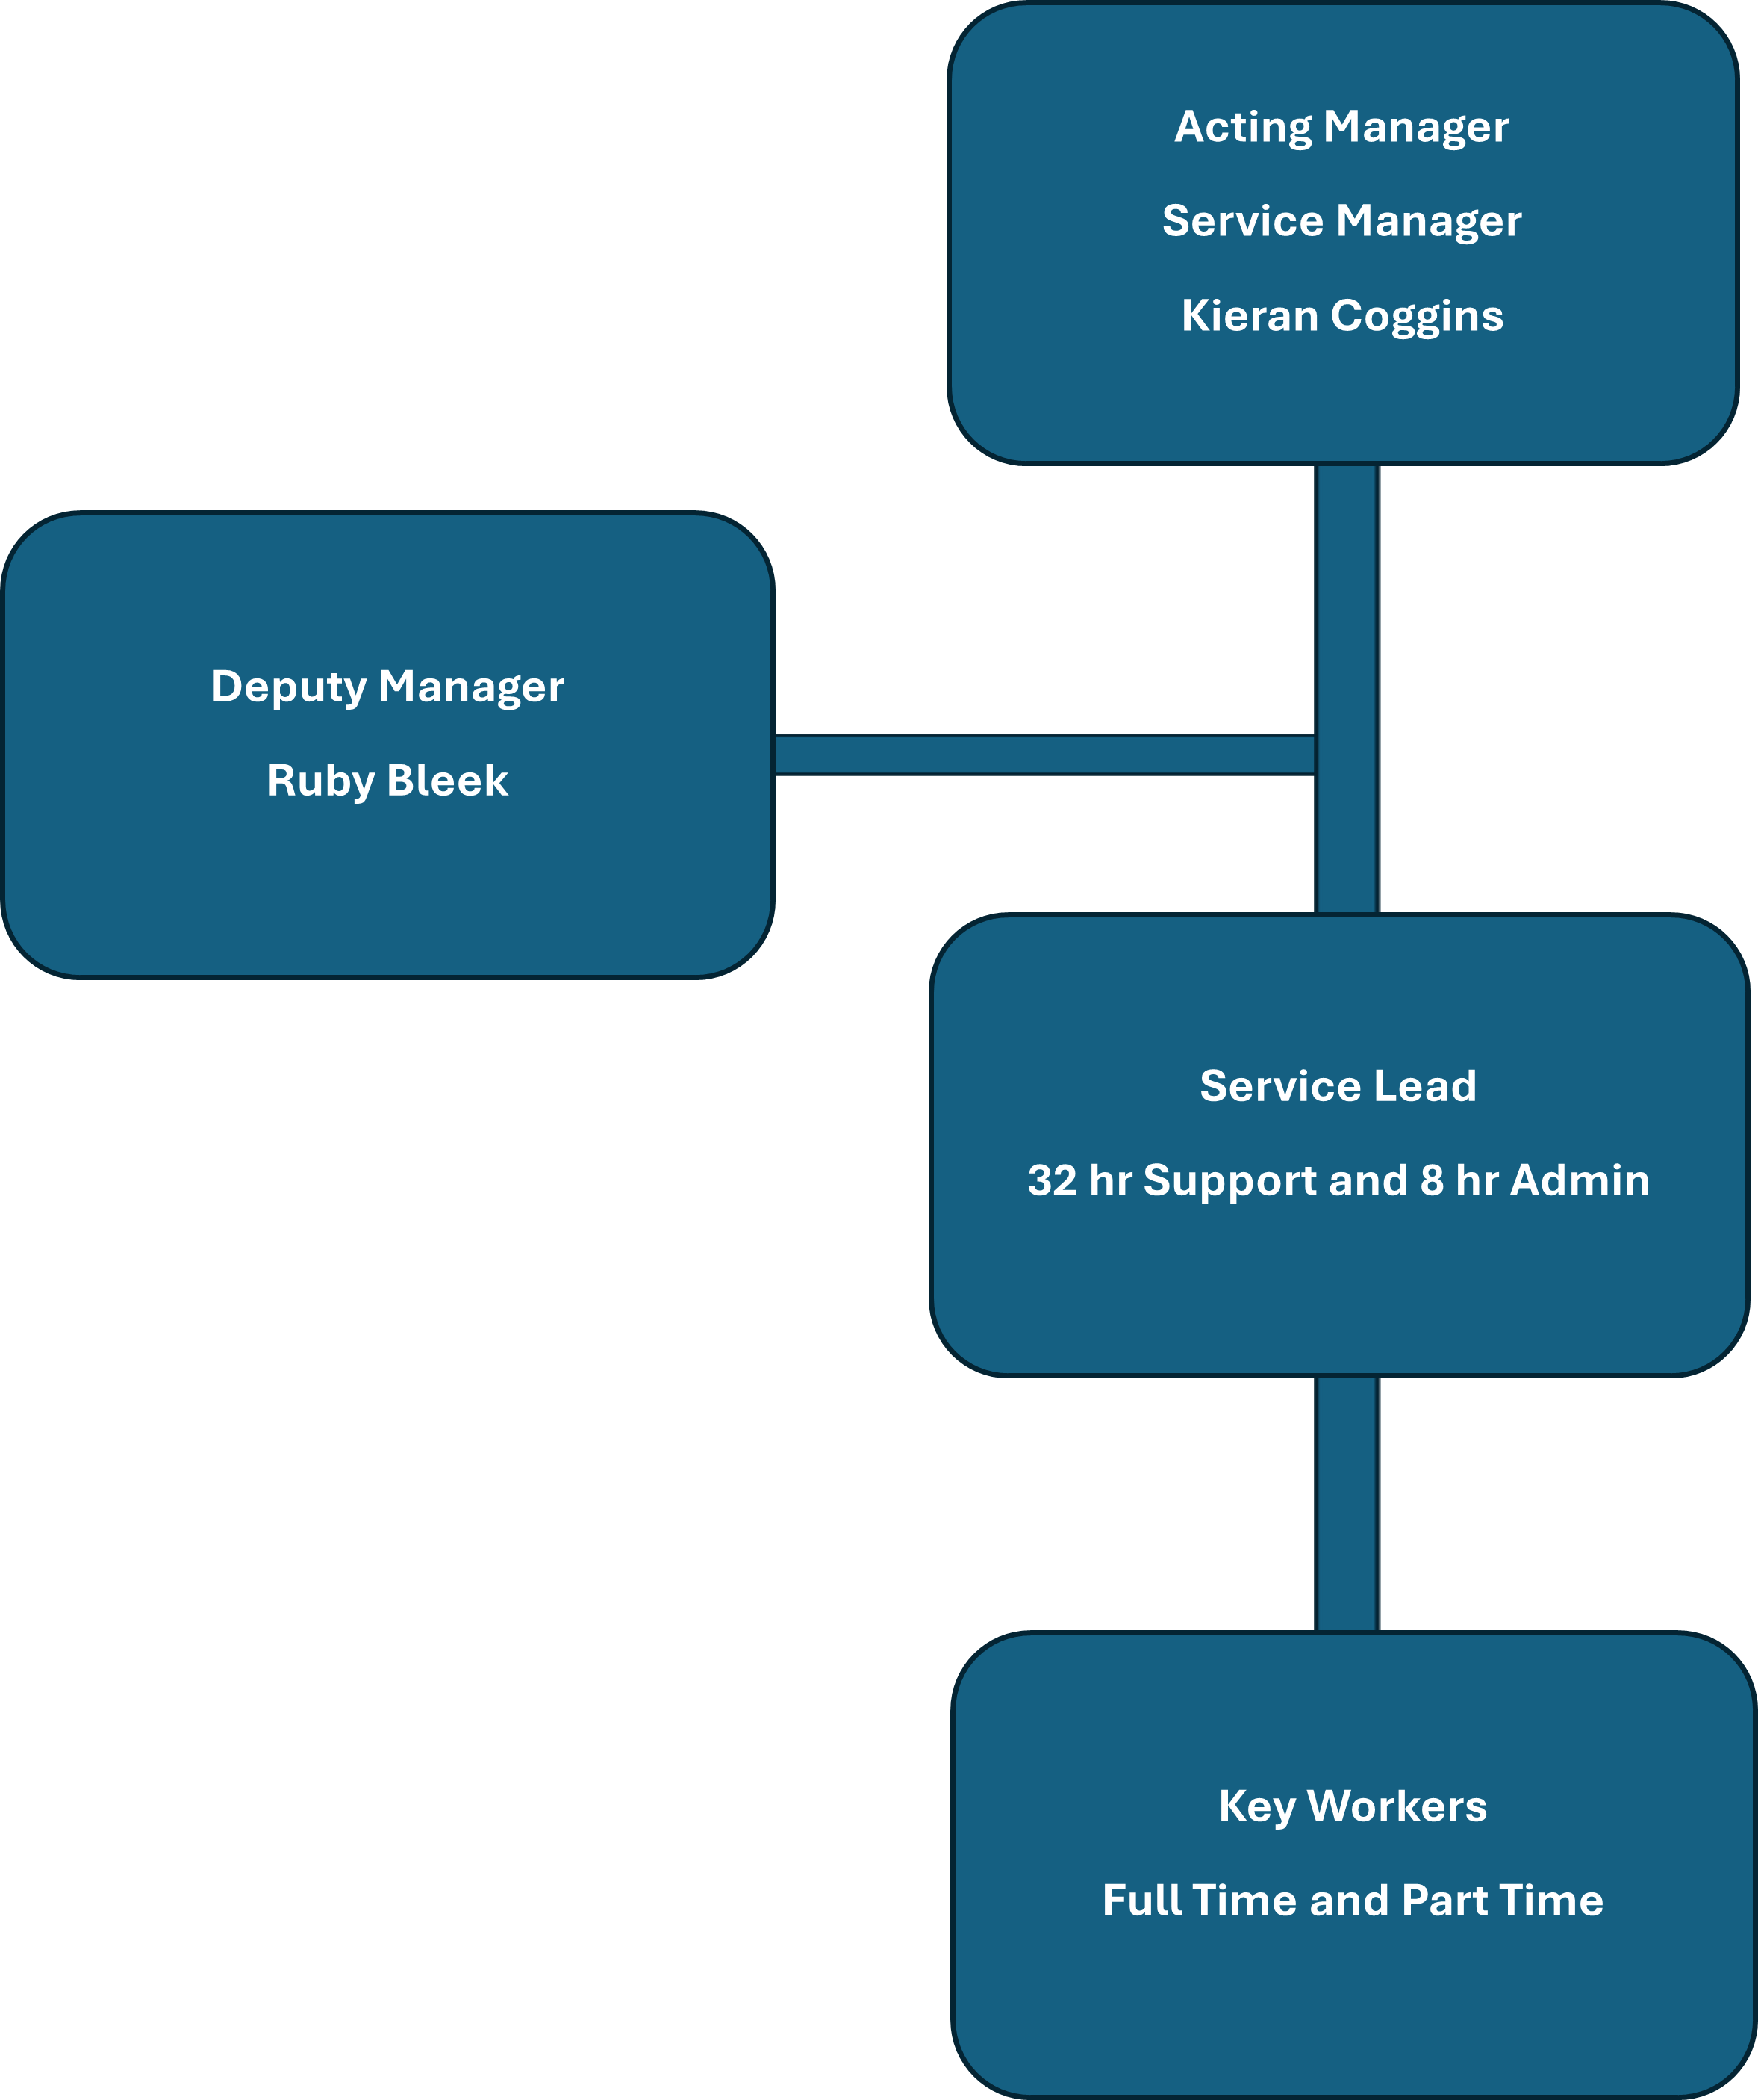

- Leadership & Management Standard
Our Service Leadership & Management Team
 | Nominated Individual: Gareth Herbert
 | Role, Qualifications & Experience
Gareth has been employed by Safe Haven Accommodation since February 2022 and has worked within supported accommodation for over 11 years.

Prior to this, Gareth trained and worked in schools in London in deprived areas. Gareth has held various roles in supported accommodation services and is now the Service Director for this service with Safe Haven Accommodation. Gareth holds the QCF level 5 qualification in leadership and management and a Level 3 in Managing Human Performance and level 3 in time management.

 | Registered Service Manager: Kieran Coggins
 | Role, Qualifications & Experience
Kieran has 12 years’ experience working within the Health and Social Care Sector. He has his level 3 in Health and Social Care and is working towards his Level 5 in Leadership and Management. He has worked for Safe Haven for over 3 years and during this time has progressed from Service Leader to Deputy Manager and is now Registered Service Manager.

Prior to working in Safe Haven Kieran worked with adults with learning disabilities within a care home. This provided Kieran with the experience around working with different disabilities and difficulties, Kieran worked as a Team Leader in this role which gave him the foundations of Leadership and Management. Kieran is qualified in Level 5 Safeguarding and is currently working towards his teaching certificate to provide training internally.

 | Deputy Manager: Ruby Bleek
 | Role, Qualifications & Experience
With over nine years of experience supporting young people and young adults with learning disabilities, Ruby has developed extensive knowledge and expertise in delivering high-quality care and support services. She is a qualified Teaching Assistant and is currently working towards her Level 5 qualification in Leadership and Management.

Ruby has been part of Safe Haven for more than three years, during which she has shown exceptional dedication and progression. Starting in the role of Service Leader, she has since advanced to Deputy Manager, reflecting her strong leadership abilities, commitment to service excellence, and ability to support both staff and service users effectively.

Prior to joining Safe Haven, Ruby worked within respite and supported accommodation services for young adults with learning disabilities. This experience enabled her to develop a broad understanding of a wide range of disabilities, additional needs, and behavioural challenges. Her progression to Assistant Manager within this setting further strengthened her leadership, organisational, and management skills, providing her with valuable experience in team coordination, service delivery, and person-centred support.
Service Offering:
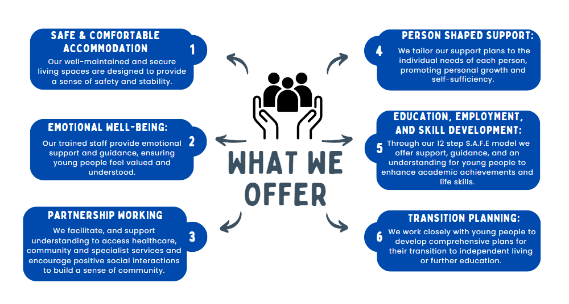
Safe Haven Accommodation offer a range of services that meet the diverse needs of young people, including:

Type Of Support We Offer:
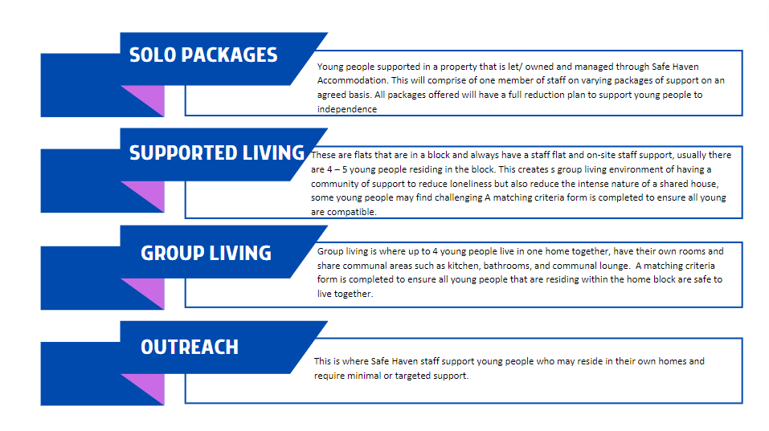
Who we can support:
Our registration with OFSTED is for 16–18-year-olds, however, we can support young people after the age of 18 in communication with the placing authority. We can support young people of all genders, sexual orientations, and cultural beliefs. In our accommodation we can have children and adults living together, but only if a child turns 18 whilst living within the accommodation.
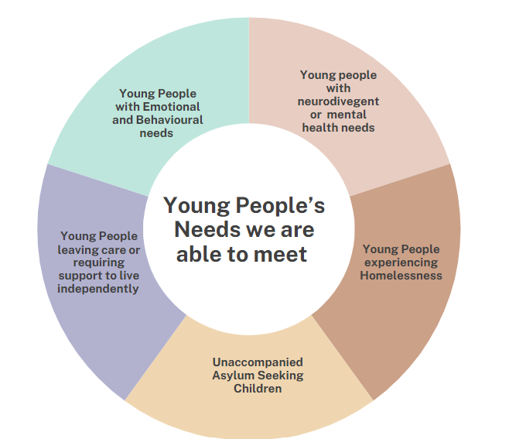
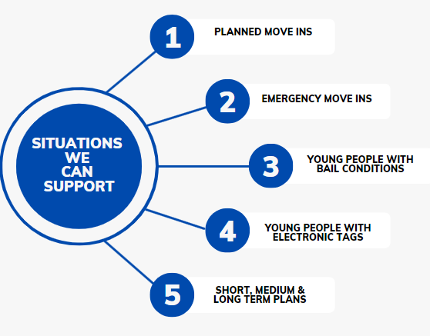

We recognise young people transition from a variety of environments and we can support them with specific needs such as medication and finances whilst adjusting to higher levels of independence. This will be supported with a clear and robust support step-down plan to ensure this need is transitioned down at the required pace to allow young people feel confident to manage their own independence. This will be reviewed at regular intervals and ensure the young person's progress and views are central to this.
We would be unable to support the following needs and circumstances:
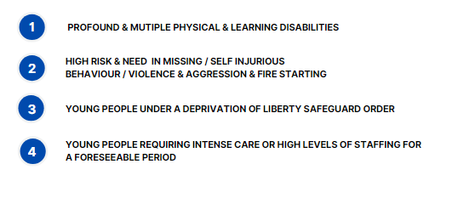
Where we can support
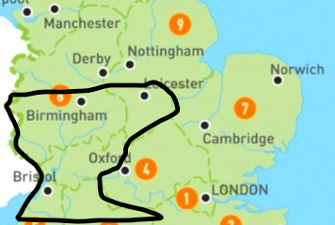
The service is spread out across several counties and can therefore support differing authorities, our current primary location is Bristol, however, could include Wiltshire, Somerset, Oxfordshire, Warwickshire, and other neighbouring counties.

Referral & Admission Process
We have a central referral team that manage all referrals made to Safe Haven (Support – Care – Education) Group and those received in relation Safe Haven Accommodation, and they will liaise with placing authorities throughout to ensure a smooth and stress-free process. For supported accommodation services specifically, the referrals team will use a dedicated admissions screening tool to initially assess young people’s needs, which will be shared with the Registered Service Manager for further assessment involving collaboration with all identified services and an assessment of risk and complex needs, followed by a sign off procedure that is approved by the Nominated Individual. This process is designed to allow full oversight by the Registered Service Manager and ensures suitability of the placement for the services offered by Safe Haven Accommodation.
Referrals are received via our central referrals team:
Email: | referrals@safehaven-group.co.uk | Telephone: | 0115 998 6734

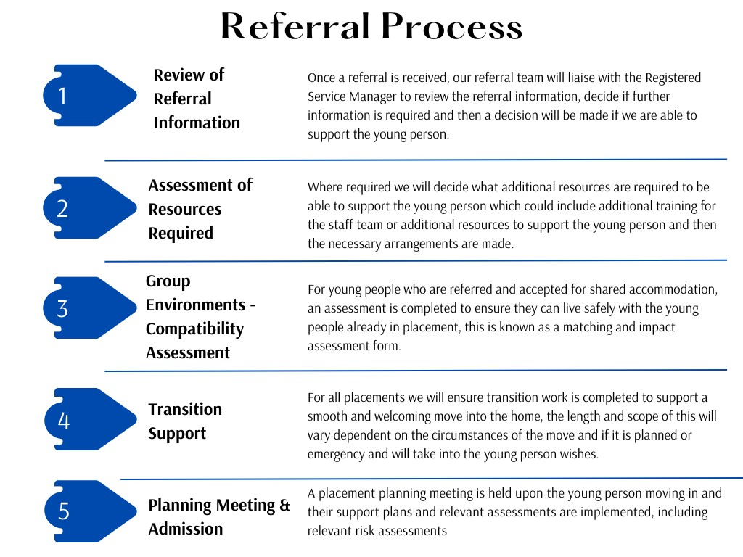

Staffing arrangements:
In our service, our overarching aim is to maintain consistency in staffing, enhancing the quality of care and support provided. This strategic staffing model reflects our commitment to delivering person-centred services while prioritising the well-being and development of the young people who live in our services. Our staffing arrangements are meticulously planned, ensuring efficient and consistent support for our young people.
Key workers are essential members of our team, fully immersed in the homes of young people, providing continuous and personalised support. Key workers work on a rota basis working directly in our homes supporting the young people to gain independent living skills. Shift times are full days to maintain consistency for both young people and staff.
Service Leaders, responsible for a small caseload of up to four young people, play a pivotal role. They act as the lead person for each individual, dedicating their week to their allocated homes with their assigned young people and an additional time to complete administrative tasks and lead their teams of support staff. This focused approach allows for personalised attention and tailored support. Service Leaders ensure that Ruby is kept informed on all aspects of their progress and any concerns that may arise for immediate action and support to be implemented.
The service is led by our dedicated Registered Service Manager, Kieran Coggins, who has full-time administrative and oversight responsibilities, and Deputy Manager Ruby Bleek who supports the Registered Service Manager in a full-time administration role and deputizes in Kieran’s absence. This leadership duo oversees the overall functioning, management, and governance of our services, guaranteeing compliance and high standards of quality support.
Our services are predominately lone working environments; however, we recognise that in circumstances there may be a need to increase this for a short period of time, or to support with a transition from a different environment. Where our service can support this, it will require an agreed time frame and plan to step down with regular reviews as a muti agency team.
Rota Management
The rota is managed by Kieran and Ruby with the support of the service leaders. Due to the nature of the support young people receive and the changes in hours of support they receive, which include reductions as they progress through to independence, we operate a rota system through Rota Cloud which enables the staff to check in for the support through the staff app, which will publish a GPS location and provide assurances of their safety.

This is a web-based system that gives staff up to date access to their rota’s, changes and new rotas implemented. This also gives Kieran and the team instant access to ensure there is governance in relation to staff whereabouts and young people support. Rotas are planned a minimum of four weeks in advance, promoting stability and predictability for both staff and young people.
Casual Staffing and Agency Staff
At Safe Haven (Support, Care, Education) Group, we acknowledge that, from time to time, the use of casual and agency staff will be required. The Registered Service Manager maintains a list of casual and agency staff that they have been involved in, and signed off, the safer recruitment process and evaluated their experience and qualifications to make them suitable for the role. All casual and agency staff undergo the same corporate induction and training week as our core staff, alongside a local induction for property and young person they work with, ensuring seamless integration and maintaining the high quality of care synonymous with the Safe Haven Group.
Workforce Development Plan
The Workforce Development Plan, as mandated by Regulation 10, plays a pivotal role in shaping the recruitment and employment practices of all staff within our service. Our plan outlines the management and staffing structure and establishes clear processes and timelines for essential components such as induction, probation, and core training, including specialised training.
Our plan details our processes for managing and improving performance, providing our structured approach to address poor performance when necessary. The plan details our supervision and monitoring processes ensuring we deliver ongoing support, feedback, and the continuous enhancement of staff skills and competencies. We keep the workforce plan under regular review, and it is available upon request.
Recruitment & Onboarding
Staff are recruited and the process is managed by our central recruitment team based at our head office function in Nottingham. A rigorous system that ensures safer recruitment best practices for onboarding staff is completed which includes DBS checks, referencing, oversees checks (where required), DBS assessments for senior manager approval where required, all monitored, reviewed and signed off by Kieran at each stage of recruitment and before employment can commence.
Induction and Probation period
All staff receive a company and local induction, and a robust and supportive probation period. Our extensive six-month induction and probation program & workbook has been crafted to ensure a supportive integration into our organisation and service. The first week encompasses a comprehensive corporate and local induction, supplemented by mandatory training sessions and policy readings. The subsequent months, structured around themed focuses, delve into diverse aspects of the role and our organisational values.
Throughout this period, monthly reviews during supervision meetings provide crucial checkpoints, fostering open discussions, offering feedback, and facilitating the sign-off of competencies. Additionally, competency exercises ensure not only the acquisition of knowledge but also its practical application in the day-to-day responsibilities of the role. As the six-month mark approaches, a rigorous probation review is completed with the staff member focusing on their development performance, achievements, and overall alignment with our team dynamics.
Completing this induction and probation period signifies the official sign-off, marking the staff member's transition to a permanent position within our team. We believe in the importance of this structured approach, ensuring not only a smooth onboarding experience but also setting the foundation for sustained success within our service.

Training & Development
Safe Haven Group places paramount importance on comprehensive training to ensure compliance with regulations and the delivery of high-quality services. Recognising the significance of training in meeting regulatory standards, Registered Service Managers deliver face to face training to their teams and where they are unable to do so training is sourced externally. There is a dedicated training tracker that supports with monitoring refresher dates for employee training compliance, some face-to-face courses include specialised subjects such as Safeguarding, First Aid, CPI, and Fire Marshall.
Our commitment to continuous learning is evident in our use of various delivery modes, including web-based training via The Vocational Training Hub, virtual online sessions through internal platforms, and face-to-face training. Safeguarding training, a critical component, is exclusively delivered face-to-face by our qualified in-house trainers. This meticulous approach to training not only ensures adherence to regulations but also equips our staff with the knowledge and skills necessary for the effective delivery of our services.
Supervision, Continuous Professional Development & Appraisal
Our commitment to staff development is reflected in our robust system of supervision, continuous professional development (CPD), and annual performance appraisals. Regular supervision as per our policy ensures that all staff members receive ongoing support and guidance, with established support networks in place to aid in their integration and professional development. Additionally, our team undergoes yearly performance appraisals, providing a comprehensive evaluation of their contributions and achievements. To further enhance individual growth, each staff member is equipped with a personalised Continuous Professional Development (CPD) plan, ensuring a structured approach to their ongoing learning and career progression.
- Protection Standard
Designated Safeguarding Leads:
Safe Haven (Support – Care – Education) Group have 8 appointed Designated Safeguarding Leads (DSL), this includes the Nominated Individual, Registered Manager and Deputy Manager per region and our Quality Assurance and Training Manager. Our Safeguarding leads have received relevant training accredited to Level 3 Designated Safeguarding Lead to hold the titles.
Our DSL’S for the South are as below:

Gareth is overall DSL for Safe Haven Accommodation; Kieran will be the DSL for the South Region and Ruby will deputise in Kieran’s Absence. Additionally, to these people, all Service Leaders have completed the Designated Safeguarding Lead training for their professional knowledge and to ensure robust leadership across the region.
Case Records
Our Record Management Systems & Approach
Save Haven (Support – Care – Education) Group have purchased the license of Lief and implementation of the software commenced 05/01/2026. Lief is a software solution specifically designed for the management of children’s social care settings. It enables the storage and exchange of important care information as swift and seamless as possible. Lief is an online, cloud-based system, which staff log on to from company laptops or mobile device that has internet access. Lief improves productivity by enabling us to store all our essential data easily and securely, while safeguarding against poor practice through improved monitoring and management. With digital forms and mandatory fields, all relevant information is collected and can be viewed, exported and shared to evidence outcomes, demonstrate compliance or just build a broader picture of a young person’s needs.
Internal Users
Every staff member gets their own user account designed for their specific role, making sure they only access the information they need. Our system keeps young people's data safe by regularly updating passwords and has the function to allow us to limit staff logins to specific IP addresses should we require to use this. In case we bring in agency staff, they can securely access records through a dedicated login on the house laptop, restricted by IP address. This ensures all records are properly completed, dated, and signed, allowing the agency to view necessary documents for safe and supportive support for the young person.
Risk Management and Oversight
At Safe Haven Accommodation, we take a pragmatic approach to risk management, aligning with the stipulations outlined in supported accommodation regulations.
Kieran, Ruby and the Service Leaders conduct fortnightly risk management meeting to thoroughly assess and address potential risks for each young person. The focus is on swift and effective support measures, with ongoing updates to the risk assessment protocols. This proactive risk management ensures robust sharing of information and a collaborative approach to risk management, including a comprehensive examination of risks and personalised support measures. The risk management meeting includes a review of a detailed risk register and a detailed meeting minutes and action plan. This reflects our commitment to transparency and accountability and our dedication to creating a safe and secure environment for the young people in our service.
Out of Hours Support Service:
Safe Haven Accommodation operate an out of hours support line for young people to access during evenings and weekends to ensure the availability of 24-hour support. The On-Call number for the service is 07588 604437
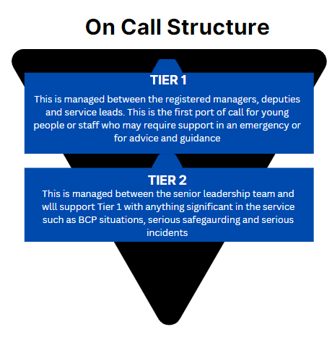
Policies & Procedures
Safe Haven (Support – Care – Education) Group has a wealth of policies that are held centrally via Lief to enable staff to have immediate access to current and updated policies. Policy reading confirmation is confirmed by each employee through electronic signature on Lief and is monitored by our central HR team and the Quality department have overall responsibility to ensure that polices are reviewed within time scale. All policies are signed off as compliant by the Service Director and Operations Director.
Safe Haven (Support – Care – Education) Group Policy Committee
The Safe Haven (Support – Care – Education) Group Policy Review Committee oversees all policies. The committee is made up by representatives from the following departments, Quality, Training and Development, HR, Maintenance, Operations and a representative (either NI/RI or RSM) from each service. There is also an opportunity for individuals using our services to attend and be involved in these meetings. The aim of the committee is to ensure policies stay relevant, compliant, safe, effective, and in line with Safe Haven (Support – Care – Education) Group’s goals.
The committee are responsible for meeting on a quarterly basis to discuss and review all policies and if there are any required updates or changes required in line with legislation, regulation, best practice or feedback from internal or external stakeholders. Members can suggest changes, ensuring our policies meet new laws and our evolving needs. Each policy is thoroughly reviewed in full at least once a year to keep them up-to-date and effective.
Safe Haven (Support – Care – Education) Group Policies
At Safe Haven (Support – Care – Education) Group, we prioritise safety and excellence in all aspects of our operations. Our comprehensive policies span crucial areas such as HR, Health and Safety, Maintenance, IT, Finance, Quality, Training, and Recruitment. These policies form a solid framework, guaranteeing uniformity, compliance, and a secure foundation for our services, team members and those we support. This centralised approach to these policies seamlessly align with our organisations values and nurture a culture of safety, integrity, and continual enhancement throughout our entire organisation. A full list of our policies and procedures for Safe Haven (Support – Care – Education) Group can be requested:
Safe Haven Accommodation Specific Policies
Specific policies have been devised for Safe Haven Accommodation that give a clear understanding and expectation to all staff across the service and act as a guide to ensuring that high quality support is provided to young people residing with Safe Haven Accommodation and their competence and understanding are reviewed through supervision, appraisals, and internal quality monitoring visits. A full list of our policies and procedures for Safe Haven Accommodation can be requested:
Accessing Policies & Procedures
Policies can be accessed through an external log in for stakeholders for Lief and can be requested during the referral process or at any other time and will be sent over as per request.
Safeguarding & Whistleblowing
In adherence to supported accommodation regulations, our commitment to robust safeguarding procedures is evident in our systematic approach. Concerns related to the safeguarding of a young person are meticulously recorded using Lief and this utilises its designated functions for notifications and an escalation process within our organisation.
As per our Regulation 20 and our SHSA-PS-001 Safeguarding Children Policy our approach and principles to Safeguarding are:
Principle | Description
Prevention | We are committed to taking proactive measures to prevent harm, abuse, exploitation, and neglect of young people who we support.
Protection | We will respond promptly and appropriately to any safeguarding concerns, taking immediate action to ensure the safety and well-being of young people, including reporting incidents to relevant authorities when necessary.
Support | We recognise the importance of providing support, guidance, and resources to young people, families, and staff members to promote a safe and supportive environment.
Education | We are dedicated to raising awareness and providing training to equip our staff and stakeholders with the knowledge and skills required to fulfil their safeguarding responsibilities.
Collaboration | We actively engage in collaborative efforts with external agencies, partners, and the local community to strengthen our safeguarding measures and promote the best interests of young people.

Our safeguarding policy provides comprehensive coverage across various domains to ensure the holistic protection of young people in our service. It begins by outlining protocols for general safeguarding, establishing a framework for creating a safe and supportive environment conducive to the well-being of all individuals. Within this framework, specific attention is given to addressing instances of abuse and neglect, with clear guidelines delineating the recognition, reporting, and response procedures for suspected cases. Additionally, the policy elaborates on the handling of disclosures and allegations, emphasising the importance of listening to and supporting young people who come forward with concerns, while also ensuring that investigations are conducted sensitively and impartially.
Allegations, Disclosures & Whistleblowing
If the concern pertains to the conduct of a staff member, our transparent disclosure process comes into play. A comprehensive "disclosure report" is promptly submitted via Lief and marked as sensitive. This will ensure it is directly notified and only accessible to the Registered Service Manager, who also serves as the Designated Safeguarding Lead. This report undergoes a thorough review, and subsequent decisions are made on whether it necessitates referral to the Local Authority Designated Officer (LADO). This structured procedure exemplifies our commitment to maintaining a safe and protective environment for the well-being of the young people in our service.
Allegations about Safe Haven Accommodation can be made independently to the following:
NSPCC | You can contact the NSPCC Helpline by calling 0808 800 5000.  Emailing help@NSPCC.org.uk or completing our report abuse online form.  Our voice Helpline is currently available 10am–8pm Monday to Friday. You can still email help@NSPCC.org.uk or complete our report abuse online form at any time for free.
Ofsted | enquiries@ofsted.gov.uk or Tel: 0300 123 1231
Local Authority | Local Authority have safeguarding procedures where referrals about concerns regarding a child can be submitted this is found on the Local Authorities Website.
Children’s Commissioner | Email: help.team@childrenscommissioner.gov.uk  Freephone: 0800 528 0731

Exploitation
Furthermore, our SHSA-PS-001 Safeguarding Children policy extends its focus to the critical issue of exploitation, encompassing various forms such as sexual, criminal, and financial exploitation. Recognising the multifaceted nature of exploitation and its potentially devastating impact on young people, the policy adopts a proactive stance towards prevention, early identification, and intervention. It underscores the importance of education and awareness in equipping young people with the knowledge and skills to recognise and resist exploitation, while also providing clear guidance for team members on identifying and responding to signs of exploitation.
By addressing these key areas within our safeguarding policy, we aim to create a protective framework that not only mitigates risks but also fosters a culture of empowerment and resilience among young people. Through proactive measures and a steadfast commitment to safeguarding principles, we endeavour to uphold the highest standards of support for all individuals within Safe Haven Accommodation
Self-Injurious behaviour
In addressing incidents of self-injurious behaviour (SIB), our approach is founded on a supportive perspective, seeking to understand the underlying causes and meet the needs of young people in a compassionate manner. While we are unable to provide constant supervision or implement “suicide watch” in our environment for a prolonged period, we strive to support individuals in managing their behaviour, collaborate with the multi-agency team and accessing appropriate resources for assistance.
Online Safety
Safe Haven Accommodation recognises technology as an integral part of young people's lives, our online safety policy operates from the standpoint of promoting safe and responsible use of digital platforms. While we cannot consistently monitor or check devices, we emphasise the importance of educating young people on online safety practices and empowering them to navigate digital spaces securely. At Safe Haven Accommodation we view the removal of technology as an absolute last resort.
Missing Persons
Aligned with police national guidance, our missing persons protocol ensures a coordinated response to incidents involving young people staying away from their home. We adhere closely to the established procedures outlined in the police national guidance on missing from home, which provides a framework for our response strategy. Our collaborative approach involves working hand-in-hand with the young person to gather crucial information about their whereabouts and circumstances. Through open communication and partnership with the young person, we aim to obtain as much detail as possible to aid in locating them swiftly and ensuring they are safe and well. Additionally, our protocol includes conducting safe and well checks to assess the young person's well-being and provide immediate assistance if needed. If our assessment is the young person is safe and well then this will be reported as unauthorised absence, if they are any concerns or we are concerned for their safety and / or no contact with the young person we will report them missing. By following these comprehensive procedures in line with police guidance, we demonstrate our commitment to prioritising the safety and welfare of young people in our service during missing incidents.
On the young person’s return we will complete a return home discussion and notify the placing authority of the young persons return to ensure they can comply with their statutory duty of ensuring an independent return home interview is completed for the young person.
Additionally, our overnight visitor’s policy outlines procedures for supporting friends visiting and staying overnight, while also addressing unauthorised absences. This framework ensures that young people are aware of expectations regarding visitors and helps support young people experience the everyday positive experiences of being a young person and spending time safely with friends and also mitigate risks associated with unauthorised outings.

Complaints:
How to make a complaint
Safe Haven (Support – Care – Education) Group is committed to offering a good, quality service, however, appreciates there may be occasions where a person may wish to raise a complaint or concern, the procedure for making a complaint is by contacting:
Email: complaints@safehaven-group.co.uk Tel: 0115 998 6734
If a complaint is serious and falls under the reporting regulation (Reg 27) category We will submit a written notification to OFSTED. Alternatively, you can also make a complaint directly to Ofsted if you have concerns about the quality of support being received:
Email enquiries@ofsted.gov.uk or Tel: 0300 123 1231
Complaints about Safe Haven Accommodation can also be made to the following people:
Children’s Commissioner | To the Children’s Commissioner  Email: help.team@childrenscommissioner.gov.uk.  Confidential complaints line help at hand: https://www.childrenscommissioner.gov.uk/help-at-hand/  Freephone: 0800 528 0731
Placing / Local Authorities | Each placing and local authorities have their complaints procedure on their website. Additionally, this information is collated in the young persons Key Contact Details Form, so all young people and team members have access to this.
National Youth Advocacy Services (NYAS) | NYAS can be accessed by visiting their website www.nyas.net. If young people need some advice or support, they can get in touch with someone who will act as their advocate on: Young people can contact the NYAS team calling 0808 808 1001. They will listen to their concerns, discuss their situation, and provide them with the help and support they need. Their advocacy and support helpline opening hours are Monday to Friday, from 9am to 8pm.

Young people:
Young people have access to the complaint’s procedure as part of their moving in welcome pack (Your Guide) and this is explained by their key worker via moving in key work document. They are able to make a complaint verbally to their staff or service lead who will record on Lief, and this will follow our process of managing complaints.
They also have access to online access to complaints form that is provided to them within their welcome guide and also within posters in their homes. This complaints form is accessible to both Manager and Deputy Manager who will take time to respond to the complaints with support through service leaders. Young people also are able to provide feedback around the support that they receive through an online form accessed using a QR code.
Our Process to Managing Complaints
The Registered Service Manager leads all complaints and outcomes, and these are recorded and logged in our central system, Lief to ensure transparency and ongoing learning and reflection.
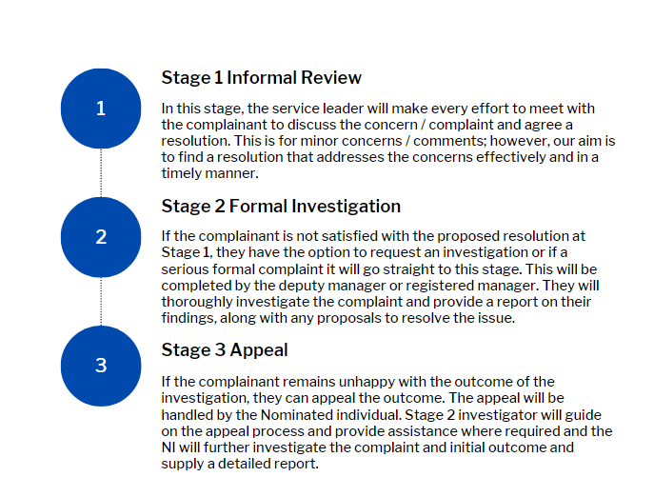
Anti-discriminatory practices in respect of children and their families:
Safe Haven Accommodation collaborates closely with the Local Authorities and local services to ensure that young people in our accommodation have access to appropriate services. We strive to establish a nurturing and inclusive environment that caters to the specific requirements of young people and their families. This involves offering mentoring, guidance, and intervention, while working closely with young individuals in areas such as Education, Employment, and Training (EET). Additionally, we focus on identifying and exploring their preferences and future aspirations, assisting them in their journey towards a fulfilling and successful future.
Our primary objective is to empower young individuals by emphasising the advantages of acquiring new skills and qualifications to enhance their employability, boost their self-assurance, and attain economic well-being. We provide comprehensive support during job searches, assist in impressive crafting CVs, conduct mock interviews, and offer financial aid for purchasing appropriate attire and essential personal protective equipment (PPE) required for interviews and work settings. We recognise the complexities of the relationships with young people and their families, where we strive to support them in a person-centred and non-judgemental way. Through our “SAFE” model, a lot of key working will be undertaken around “support networks,” in the hope we are able to forge stronger and healthier relationships between young people and their families. The ethos around our approach towards young people and their families, are captured in our “equality, diversion and inclusion policy.” Our staff receive training in this area during their induction training and familiarise themselves with the policy.
4. Accommodation Standard
Facilities:
Safe Haven Accommodation prides itself on offering good, quality facilities and accommodation to the young people it supports which include:
Virtual Tour of Our Accommodation

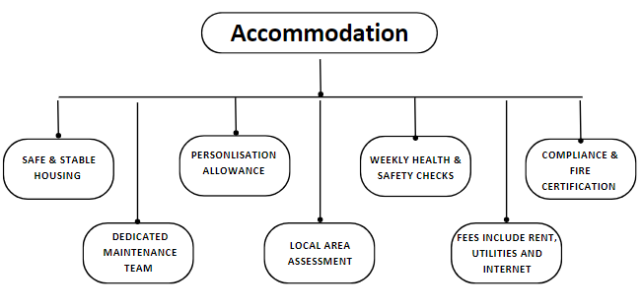
Dedicated Maintenance Team:
Our dedicated maintenance team and procedures for our service enable us to have a proactive approach to maintenance and emergencies. We are readily available to address issues promptly, ensuring that any concerns are attended to without delay. By having our own and dedicated maintenance personnel we can ensure they are a consistent figure in the lives of young people residing in our service, this ensures safety and support for the young people to have the opportunity to get to know who is coming into their home. This consistency is further promoted by providing the maintenance team with core mandatory training. This training supports the maintenance team to understand the unique needs and dynamics of the young people in our services and give them their required knowledge to support the young people when visiting.
At Safe Haven Accommodation we utilise Job Logic systems to enhances our maintenance procedures. Through this system, we efficiently allocate visits and record maintenance activities on a visible calendar accessible to both the young people and the staff team.

Location Assessment:
All homes have individual location risk assessments, and these are reviewed on an annual basis. We assess the appropriateness of our supported accommodation locations, engaging key partners in the community to evaluate safety, links, and suitability. This ensures our premises meet both regulatory standards and community-specific needs, creating a secure and fitting living environment.

Weekly Health & Safety Checks:
All homes receive weekly health and safety checks that include checks to ensure there is no damage, smoke alarms are working, the home is clean and tidy, and the young people are in a safe home that continues to meet their individual needs.
Compliance & Fire Certification:
All homes have individual fire risk assessments and the necessary checks in relation to health and safety – Gas Safety, Pat Testing & EICR.
Our Homes:
- Within all of our homes the support package offer covers rent, utilities and internet for each young person.
- All homes have Emergency Continuity Plans and Personal Emergency Evacuation Plans.
- ICE form – (In case of an emergency) that gives the young people to hand information relating to gas safety, emergency contact information.
- Young people have their own key to their home and each of our homes are fitted with Ring Doorbells to afford Staff and Young People additional security ahead of visitors being let into the home.
- All homes are furnished to a high standard that includes, communal living furnishings, bed, wardrobe, chest of drawers, bedside cabinet, lockable cabinet or safe, desk, and chair per room.

5. Support Standard
Welcome Guide
All young people receive a welcome guide called “Your Guide” when they move into their home and this holds a wealth of information including:
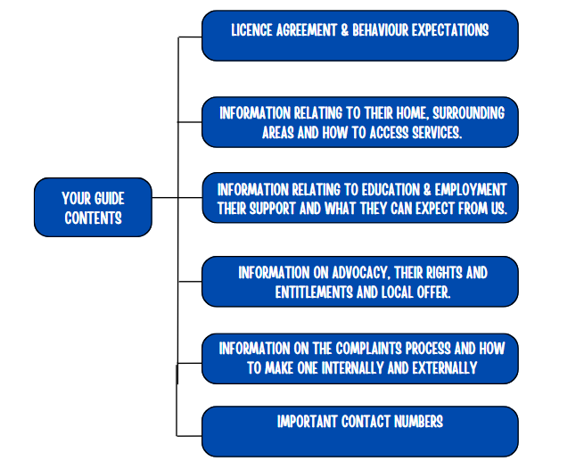

Staff are guided to go through this with them via a welcome key work document and the young people are supported to sign this and retain a copy:
At Safe Haven Accommodation we have an understanding the diverse ways young people engage; we've taken a thoughtful approach to our welcome guide. Recognizing that lengthy written documents might not resonate with everyone, we've created two versions to cater to different preferences.
For those who prefer a traditional written format, we have a comprehensive written welcome guide. However, we understand that engagement can be enhanced through more creative and visual means. That's why we've also developed a dynamic one-page profile in video format.
This video guide serves as a creative and engaging alternative, offering an animated walkthrough of essential information. We believe that accessibility is key, and by providing information in various formats, we empower each young person to engage with the welcome guide in a way that suits their unique style and preference. It's not just about information; it's about ensuring everyone feels connected and comfortable from the very beginning of their journey with us.

Written Version  Of  Your Guide  Example |  | One Page  Your Guide  Example

Behaviour Management Approach
At Safe Haven Accommodation our approach to behaviour management is centred upon a set of principles that prioritise positive communication, understanding, and respect in our interactions with young people. We recognise that each individual's behaviour is a form of communication, stemming from their unique experiences and needs. As such, our approach is centred on fostering non-judgmental and empathetic relationships, where young people feel valued, understood, and supported. We prioritise restorative practices and learning outcomes, viewing challenging situations as opportunities for growth and understanding. Through meaningful involvement, we empower young people to take ownership of their support journey, ensuring their voices are heard and respected in decision-making processes.
At Safe Haven Accommodation, our behaviour management approach is rooted in a commitment to clear communication, positive relationships, and person-centred support. We begin by setting clear expectations through documents like Your Guide and the License Agreement, followed by personalised induction key work sessions to ensure understanding and clarity. Our team members focus on building and maintaining positive relationships, tailoring support plans to meet the unique needs of each young person. Through role modelling positive behaviour and providing ongoing support, we create a nurturing environment where young people can thrive and develop independence.

Recognition and rewards play a key role in our approach, reinforcing positive behaviour and celebrating achievements. Additionally, our implementation of the S.A.F.E Independence Model guides young people in gradually gaining autonomy and responsibility as they progress in their journey. Our Behaviour management approach informs our priority is the safety and well-being of our young people, aiming to prevent unnecessary criminalisation. While restraints are not anticipated, any identified prolonged need for them would render our service an unsuitable environment to meet their needs. In serious incidents, standard protocol advises team members to withdraw and contact management or on call and if required emergency services. Young people at risk have personalised protocols in their risk assessments, ensuring a consistent approach for team members and our team undergoes rigorous de-escalation training. Although restraint use is rare, our policy addresses it for extreme emergencies, underscoring our commitment to safety with sensitivity and caution.

Through these strategies and a commitment to restorative practices, Safe Haven Accommodation aims to create a safe and supportive environment where young people can flourish and work towards a brighter future.

Police Involvement
Safe Haven Accommodation upholds a robust commitment to providing exemplary support to young people and adults across our services. When considering whether to involve the police, we meticulously weigh the rights of young people and adults, as well as those of our team members and stakeholders. It's imperative to recognise that police involvement can potentially lead to criminalisation or strain relationships between young people and authorities, with unforeseen consequences. Therefore, our team members and managers are dedicated to resolving situations supportively and restoratively, striving to prevent any unnecessary negative outcomes for the individuals involved. Understanding the heightened risk of offending behaviour among young people care experienced and are empathetic towards this and always consider the factors such as age demographics, underlying needs, peer influence, and past trauma experiences. By promoting a supportive environment and addressing underlying challenges, we endeavour to empower young people to make positive choices and avoid unnecessary police involvement.

This ethos guides our approach, ensuring that any decision to involve the police is carefully considered and aligned with our SHSA-SS-007 Police Involvement Policy, which specifies situations meriting such action are as follows:
- Violence by a young person towards another young person.
- Violence by a young person towards staff and other adults.
- Criminal Behaviour, including damage and theft.
- Disorderly Behaviour.
- Substance Misuse.
- Safeguarding Protection.
- Young People Missing from Care.

Developing Independent Skills
Safe Haven Accommodation support is underpinned by a bespoke 12-step model called Steps to Achieving Future Excellence (S.A.F.E) to support the development of independence in the young people we support. The comprehensive S.A.F.E model breaks down the transition to independent living into 12 manageable steps across all relevant areas as shown below.
S.A.F.E. Model
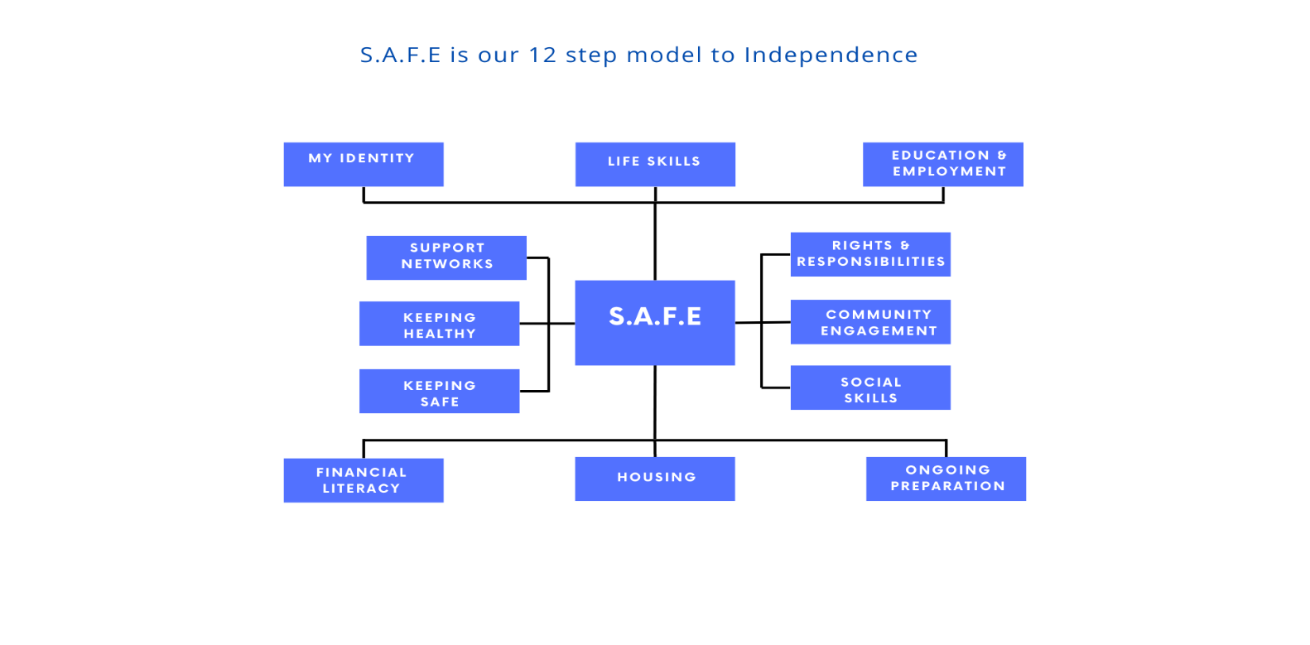

The S.A.F.E. model clearly defines the knowledge, skills, attributes, and tasks needed to develop independence across 12 steps. Utilising keywork sessions, videos, life skills materials and hands-on support, S.A.F.E. equips young people not just for their time with Safe Haven but to thrive independently thereafter. Young people are empowered to work through the steps at their own pace with ongoing guidance and support from Safe Haven staff. The S.A.F.E goal is to ensure young people gain the full range of skills, knowledge, attributes, and experience needed to feel truly safe, able, and confident to live independently and thrive as adults.
The foundational principles of the S.A.F.E Model revolve around building relationships, building trust, adopting a non-judgmental stance, and employing a creative and solution-focused approach. This model serves as a comprehensive framework, delineating the skills, knowledge, and attributes necessary for young people to transition into independent living successfully and joyfully, as outlined through its 12 steps. Each step is further defined into key focus areas, offering clear guidance to the staff on the specific areas they need to address or support within each step. Importantly, the S.A.F.E Model at Safe Haven Accommodation does not dictate a rigid teaching method. Instead, it empowers our staff to leverage their unique skills, knowledge, and experiences to understand the young person's needs and plan their support effectively.
While the model provides guidelines and inspiration, it emphasises flexibility, encouraging staff to tailor their approach to the individual. The model provides examples of activities suited to diverse learning styles to provide inspiration and guidance if required, this includes skill development, qualification attainment and broader life learning resources. At Safe Haven, our commitment is not just to instruct but to inspire, promoting a holistic and personalised growth journey for each young person in our care.
Applying the S.A.F.E Model in practice
In our day-to-day operations, the S.A.F.E Model is seamlessly integrated, as illustrated in the chart below. This integration is evident in our support plans and workbooks, demonstrating how the model guides our approach. Furthermore, the S.A.F.E Feedback and Meeting process underscores its influence on our feedback and review procedures. Notably, the model takes centre stage in our outcome monitoring, as evidenced by the SAFE Outcome Monitoring Form. This holistic incorporation of the S.A.F.E Model ensures a comprehensive and cohesive implementation across various facets of our service delivery.
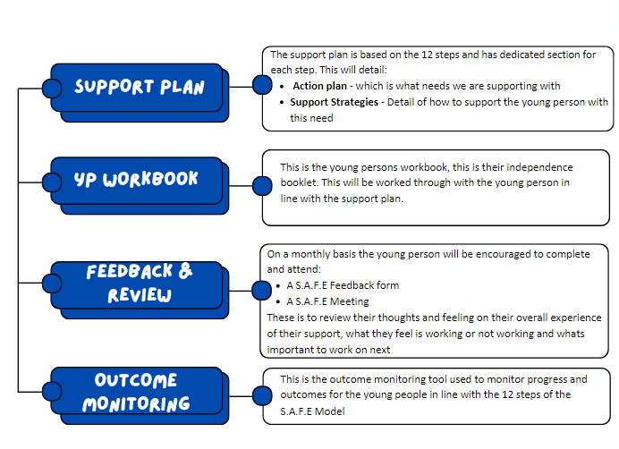
An example of the S.A.F.E Model young person’s workbook and employee guide can be found below:

S.A.F.E Model  Young Person  Workbook |  | S.A.F.E Model  Employee  Guide
Safe Model Phased Induction
The core values of the S.A.F.E Model emphasise the importance of cultivating relationships and trust. Acknowledging that establishing connections with the young people we support may require time, we have implemented a phased induction within the S.A.F.E model. This approach prioritises the initial steps of building relationships before delving into extensive teaching and developmental efforts. The 3-month phased induction can be seen in the graphic below:

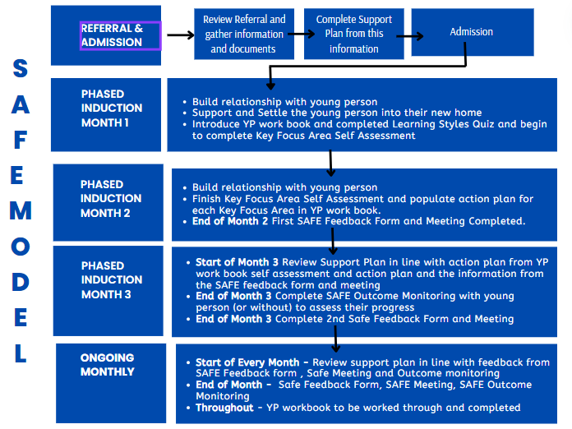

Supporting Health and Wellbeing
At Safe Haven Accommodation, we prioritise the holistic well-being of young people as an integral component of our SAFE Model, particularly emphasising the "keeping healthy" step. This step is designed to address various aspects of health, encompassing physical, mental, sexual, and diet and lifestyle considerations. To achieve this, we have identified eight key focus areas within the "keeping healthy" step, each aimed at supporting the young person's overall health and well-being.
These areas include registering at primary health services, facilitating initial check-ups, providing education on available health services and how to access them, establishing a comprehensive medical file, creating a personalised wellness routine and lifestyle plan, addressing mental well-being and self-esteem, offering guidance and support on sexual health matters, and educating on health risks.

Medication
At Safe Haven Accommodation, we won’t routinely manage medication for young people. It is expected the young people who Safe Haven Accommodation support will be able to, and have the ability and capacity to, manage their own medication.

However, there may be instances where temporary support and management of medication is necessary, such as during a transition from a care environment or for a short period of time to address specific health needs. This is limited to the storing of medication stock and does not include the administration of medication or the enforcement that medication is taken. In such cases, we will implement a clear reduction plan in collaboration with social services and healthcare professionals, ensuring that the use of medication is limited to the minimum necessary and is accompanied by appropriate support services aimed at addressing the underlying health concerns.
At Safe Haven Accommodation, the safety and well-being of our young people are paramount, especially when it comes to medication management. To ensure the highest standards, all team members undergo comprehensive training in medication administration. Before being authorised to administer medication, team members are required to undergo competency assessments to demonstrate their proficiency and understanding of safe medication practices.
Additionally, we recognise the importance of empowering young people who self-administer medication. In such cases, we provide tailored support, including setting alarms, reminders in calendars, or other appropriate measures to help them manage their medication regimen effectively.
All medication management activities are meticulously recorded through Lief in the medication cabinet (electronic) and through dispensing, administering, and disposing records for each young person, ensuring transparency and accountability in our medication practices.
Supporting Education and Employment
At Safe Haven Accommodation, our ethos centres on providing empowering support to young people as they navigate their educational and career journeys. We believe in creating a positive learning environment where each individual is empowered to reach their full potential. Our dedicated team members play a crucial role in this process by actively engaging with young people, helping them set and achieve their education and training goals, and instilling the value of lifelong learning through the SAFE model.

Education, employment, and training are integral components and a step of our Safe Model. This step encompasses various key focus areas, including exploring interests to identify potential careers or educational paths, accessing local opportunities for education, training, voluntary work, and employment, honing interview skills, developing employability skills, and crafting compelling CVs, LinkedIn profiles, and job applications. Through targeted support and guidance in these areas, we empower young people to make informed choices about their futures and seize opportunities for personal and professional growth.

Recognising the diverse challenges young people in the care sector may face, we prioritise collaboration with education and health professionals to address barriers to learning effectively. In line with our commitment to positive outcomes, our service places a strong emphasis on partnership with educational, training, and employment services. Through proactive collaboration and open communication, we ensure that young people have access to the support and resources needed for academic and professional success. Moreover, we are supportive in monitoring and reviewing young people's progress, promptly intervening if additional support is required or targets are not met. By creating an inclusive and supportive learning environment, we aim to empower young people to pursue their aspirations and lay the groundwork for a successful future.

Involving Young People in the delivery and design of their support
Young people have a dedicated service leader that will ensure they are supported whilst placed at Safe Haven. The service Leader will visit at least weekly and will have direct support sessions with the young person to ensure they have input into their support plan. Young people are encouraged to play a key role in their support plan whilst they reside with Safe Haven Accommodation and are encouraged to feedback on their views and opinions as explained in the graphic below:
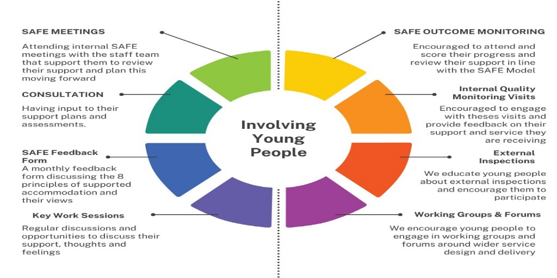
Arrangements to promote & support involvement & progress in education, training & employment:
This is achieved in line with the S.A.F.E model and individualised support plans and the support sessions young people receive. All staff are trained to deliver a supportive service that promotes emotional well-being and in turn young people are encouraged to seek education, employment, and further training and this is celebrated individually. Young people have access to care skills academy and are encouraged to complete training in fire safety, health and safety, online safety and COSHH. Safe Haven Group training, compliance and advisory manager that supports the staff team in relation to exploitation, substance misuse, self-injurious behaviour and is able to offer research and information for young people to access.
Supporting culture, linguistic and religious needs:
At Safe Haven Accommodation we understand that the needs of young people can vary widely based on their individual backgrounds and experiences. We pride ourselves on being open, adaptable, and willing to learn from the young people we support to providing effective assistance that respects their cultural, linguistic, and religious needs and identities by:
- Ensuring staff receive equality and diversity training.
- Employing a diverse staff team.
- Implementing individualised support plans and assessments that take in to account cultural, linguistic, and religious needs, dietary restrictions, prayer times, and cultural celebrations.
- Celebrate and acknowledge various cultural and religious holidays and events. This can help young people feel valued and connected to their heritage.
- Encourage open and respectful conversations about cultural, linguistic, and religious differences. This can help create an environment where young people feel comfortable expressing their needs and concerns.
- Flexible support sessions that take into consideration religious obligations, such as prayer times or fasting during Ramadan.
- Promoting inclusion and respect and fostering cross cultural friendships and learning experiences.
- Review & Updates
Date | Review & Update | Completed By
29/02/2024 | Reviewed in line with regional split and introduction of restructure. | M.Mills
08/03/2024 | Reviewed in line with clear care development and policy review | C.Rook
03/04/2024 | Reviewed in line with Ofsted Feedback during registration visit. | C.Rook
28/08/2024 | Reviewed and edited following updates to processes, changes to organisational structure and policy reviews. | M.Bareford
21/03/2025 | Reviewed and edited to provide changes to deputy manager information, further clarity to the referral’s procedure and other changes to organisational structure. | M.Bareford
15/05/2026 | Reviewed and edited to update Registered manager information, Deputy Manager information and also updates around Recording System. Removed selected unnecessary information | K.Coggins

